[bob8][개발]send_arp[정동욱]

<https://github.com/James-Jeong/ARP_Spoofing>

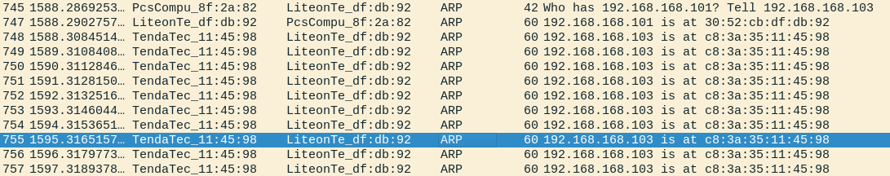

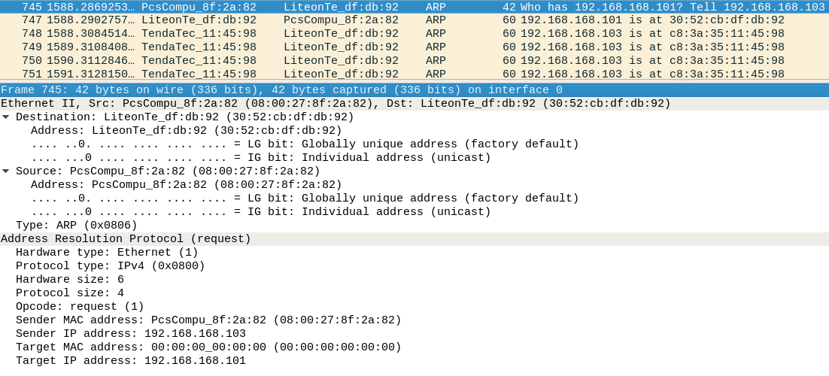

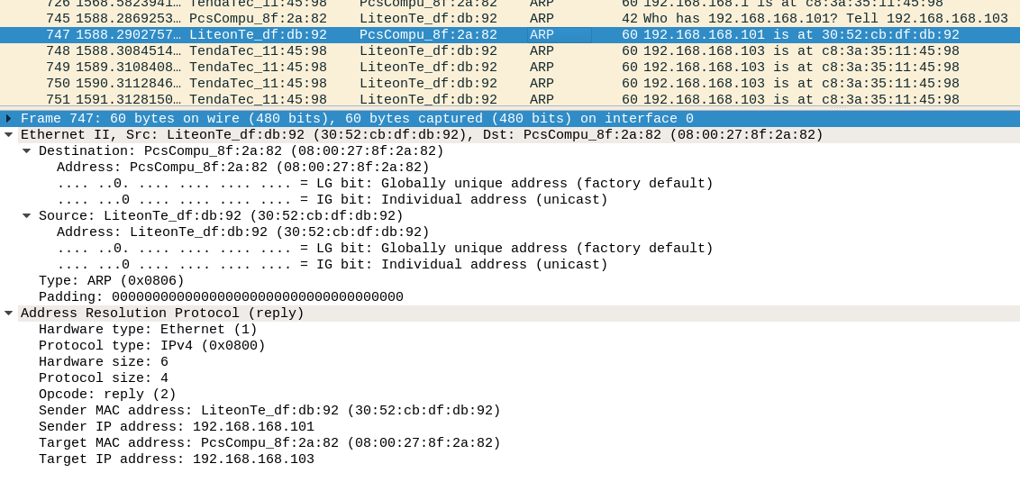

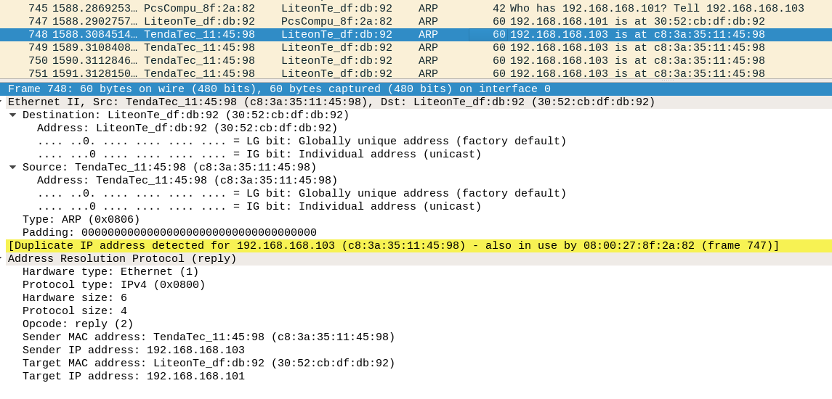

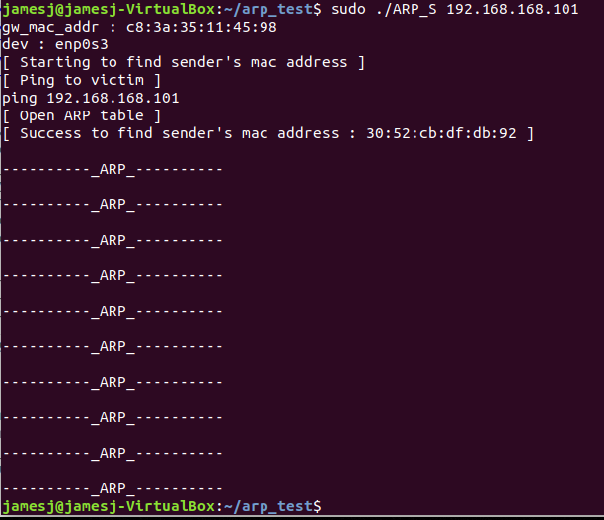

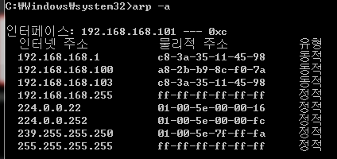

내 컴퓨터 ip address : 192.168.168.103

상대방 컴퓨터 ip address : 192.168.168.101